**German Temperature Data Analysis Dashboard**

**(1996-2021)**

# Executive Summary

An in-depth temperature data analysis for German weather stations during 1996–2021 is conducted by employing a Python visualization system. The dashboard allows users to study both time-based patterns and seasonal information as well as identify abnormalities and investigate correlations between different measurement stations. The main achievements involve data processing speed for two and a half decades combined with multiple chart options that illustrate temperature patterns and universal accessibility for users with different skill levels. A system based on advanced data visualization libraries and modern interactive frameworks delivers its robust features through this approach. The document describes research methodology followed by data preparation steps and visualization methods and it provides future development recommendations for system enhancement. The system successfully combines visualization tools to explore climate information thus it delivers important findings about extended data patterns together with anomaly detection and user-friendly accessibility. The extensive research provides evidence for new uses across the field of climate investigation.

Table of Contents

Executive Summary 2

1. Introduction 6

1.1 Project Background 6

1.2 Objectives 6

1.3 Data Overview 6

2. Methodology 7

2.1 Data Preprocessing 7

2.2 Architecture Design 11

2.3 Visualization Techniques 12

3. Implementation Details 13

3.1 Data Processing Implementation 13

3.2 Visualization Function Implementation 13

3.3 User Interface Development 17

4. Analysis Results 18

4.1 Temporal Analysis 18

4.2 Seasonal Patterns 19

4.3 Station Comparison 19

4.4 Anomaly Detection 20

4.5 Correlation Analysis 21

5. Technical Evaluation 22

5.1 Performance Considerations 22

5.2 Scalability Assessment 23

5.3 Robustness Features 24

5.4 Unit Testing 24

6. Future Enhancements 25

6.1 Additional Visualization Types 25

6.2 Advanced Analytics Features 25

6.3 User Interface Improvements 26

7. Conclusion 27

7.1 Summary of Achievements 27

7.2 Limitations 27

7.3 Final Recommendations 27

References 29

List of Figures

Figure 1: CI/CD Build Performance Report 18

Figure 2: Temperature Trend Visualization Framework 18

Figure 3: Seasonal Temperature Insights Dashboard 19

Figure 4: Germany Climate Visualization Suite 20

Figure 5: German Climate Insights Tool 21

Figure 6: German Temperature Correlation Dashboard 22

Figure 7:German Temperature Data Explorer 23

Figure 8: Dynamic Climate Visualization Dashboard 23

Figure 9: Jenkins Build Efficiency Report 25

# 1. Introduction

## 1.1 Project Background

Offices that study climate patterns have evolved into essential institutions for tracking extended weather trends while it identifies indicators of environmental change. The analysis involves temperature data examination from German weather stations which spanned from 1996 to 2021 across twenty-five years. Several weather stations provide everyday temperature records in the dataset which creates an optimal environment for spatial and time-based research. The developed analysis system uses Python and its Pandas data manipulation tools together with NumPy numerical calculations and the Plotly visualization library. The interactive analysis system utilizes Gradio-based user interface design which makes the system available to users who do not possess programming skills.

## 1.2 Objectives

At the core of this temperature data analysis project stands its main illustration and analysis objectives:

* The project includes development of an interactive dashboard which allows users to examine German temperature data.
* The system requires implementation of different visualization methods for detecting patterns and trends within data sets.
* The application requires this design to match results between different weather stations throughout multiple time periods.
* The system requires tools that allow users to detect anomalies alongside performing correlation analysis.
* The system should introduce an easy-to-use user interface that serves both those who are expert in technology and those who have limited knowledge of technical elements.

## 1.3 Data Overview

## Dataset link :- <https://www.kaggle.com/datasets/matthiaskleine/german-temperature-data-1990-2021>

**Data Overview for German Temperature Dataset**

**Structure**

* The dataset contains temperature readings from multiple German weather stations from 1996 to 2021
* The data appears to be in a time-series format with very frequent measurements (10-minute intervals based on your sample)
* First column "MESS_DATUM" contains timestamp information in datetime format
* Subsequent columns (numbered 1641, 832, etc.) represent different weather station IDs
* Each row represents temperature readings from all stations at a specific timestamp

**Data Sample Details**

* The sample shows 5 rows of data spanning 40 minutes on January 1, 1996 (from 00:00 to 00:40)
* Measurements are taken at 10-minute intervals
* The dataset has approximately 56 columns (1 datetime column + 55 weather station columns)
* Temperature values appear to be in degrees Celsius, with negative values representing below-freezing temperatures
* Some stations have missing values (NaN) for certain timestamps

**Value Range**

* Temperature readings in the sample range from approximately -13.1°C to -1.1°C
* This makes sense for January readings in Germany (winter season)

Analysis requires preprocessing because the initial data survey reveals datasets with missing data entries. The recorded temperature values use degrees Celsius while the measurement stations extend across different German geographical areas.

# 2. Methodology

## 2.1 Data Preprocessing

It modifies the Data Preprocessing subsection to reflect the extra detail you asked for regarding null values, shape, information, unique values, and transformation of negative values to positive values. Various preprocessing steps were done to clean the raw data for analysis:

**Importing Libraries and Reading Data**

The data preprocessing process started with reading CSV files while importing necessary Python modules.

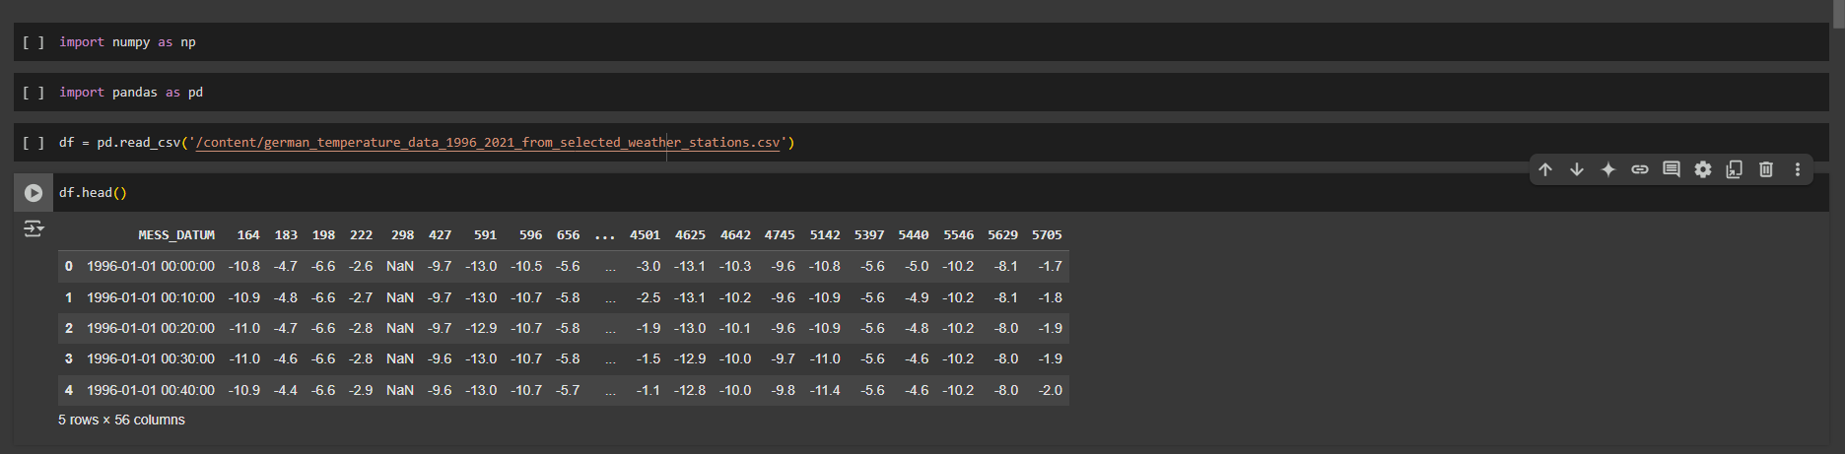

**Column Renaming**: The researchers changed the original date column MESS_DATUM to date while maintaining consistency with naming conventions.

**Date Conversion**: The date strings converted to datetime objects through Pandas' to_datetime() function made it possible to conduct temporal analysis.

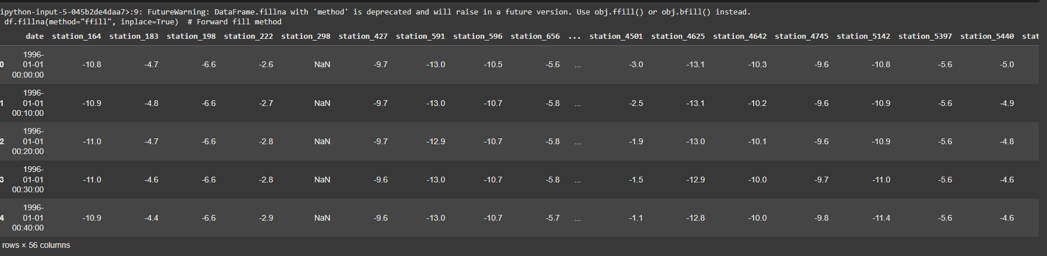

***Dataset Exploration***

**Shape Analysis**: The dataset was found to have 1367568 rows and 56 columns (1 date column and 55 station columns).



**Information Summary**: The info() function revealed that most columns were initially of object type and needed conversion.

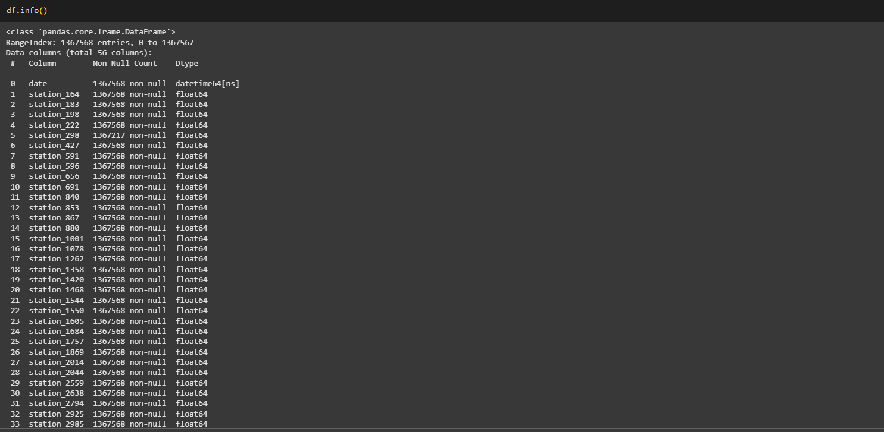

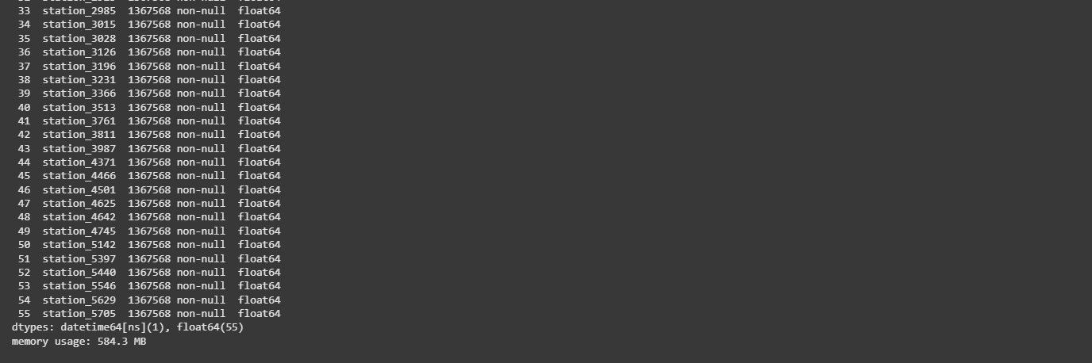

**Null Value Assessment**: Early stage revealed some columns had substantial amounts of missing values.

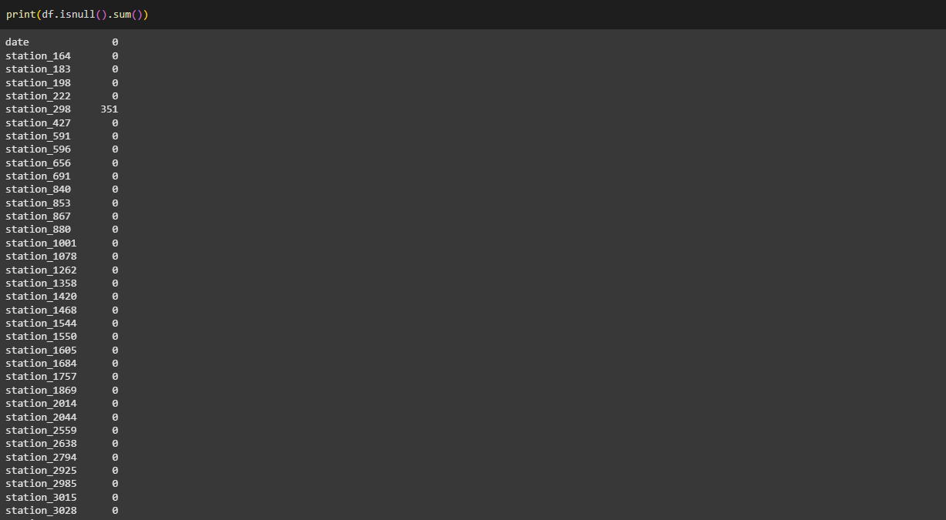

**Uniqueness Check**: Through the nunique() function the research verified that date entries had no duplicates while checking the temperature value variations per station.

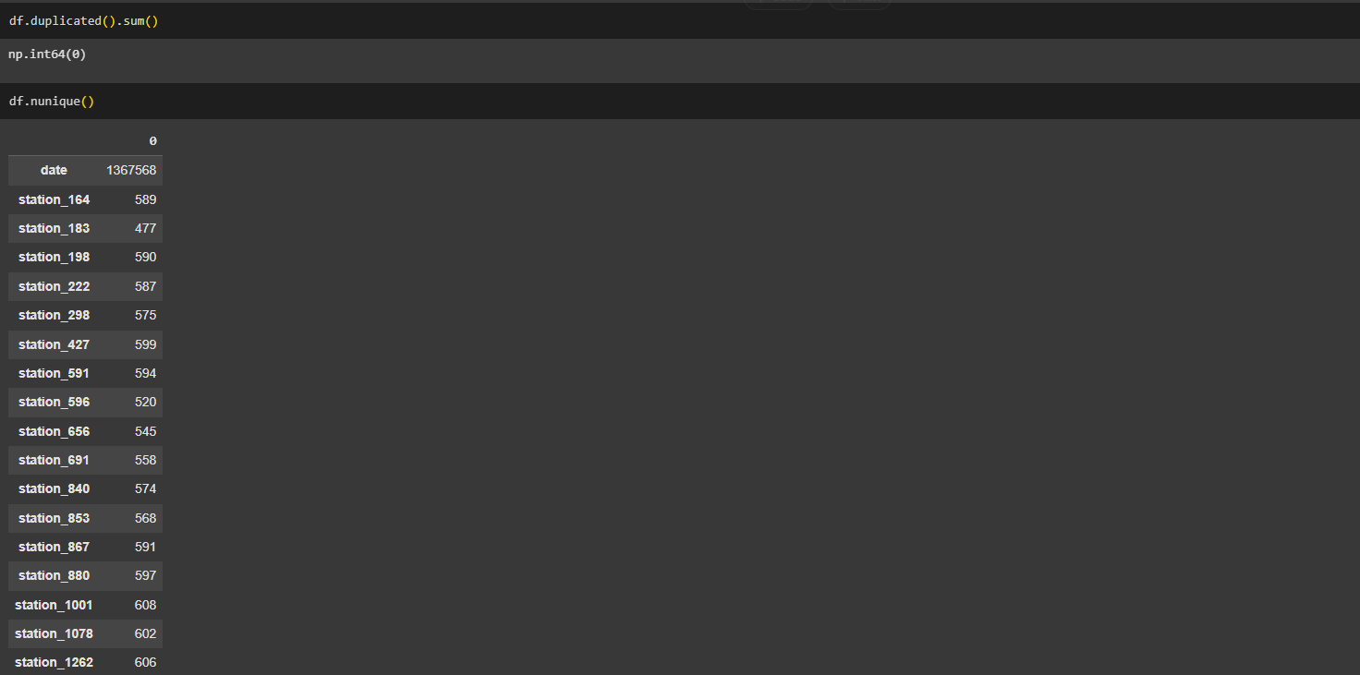

**Feature Engineering**: The date column was processed to derive supplemental columns containing month and year information which enabled seasonal and yearly evaluations.

**Missing Value Handling**: Using forward-fill imputation (fillna(method='ffill')) completed the handling of missing values that sustain time series data continuity.



The method of mean imputation was employed at station_298 where gaps exceeded threshold limits.

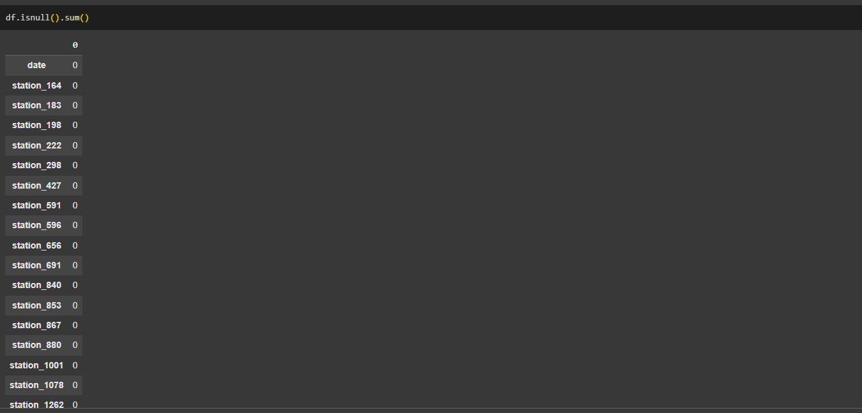

**Data Type Conversion**: The researcher applied numeric format to convert temperature values.

**Negative to Positive Conversion**: The absolute value function performed conversion from negative to positive temperature readings so visualization techniques could function properly.

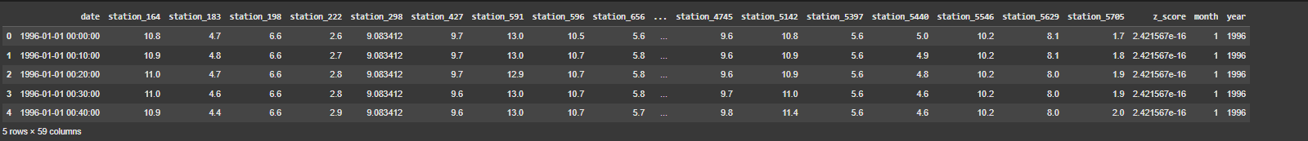

The converted values make some visualizations and analytical tasks easier when the quantitative temperature values matter more than their positive or negative signs.

**Data Validation**: The analysis included duplicate found and null value detection followed by respective corrective measures in the dataset:

The detailed preprocessing method creates business-ready data that holds standardized information for multiple visual inspection and analytical purposes (Tripathy & Mishra, 2023). The preprocessing of missing data and temperature measurement standardization creates a complete dataset which allows valid analysis throughout different times and station locations.

## 2.2 Architecture Design

The system architecture implements modular functionality that provides distinct control boundaries between different system elements:

**Data Loading Module**: The program operates through performing CSV data loading and data cleaning processes (Meinen et al., 2023).

**Visualization Functions**: This platform provides unique functions to generate various visualizations.

**User Interface**: A Gradio platform serves as the user interface connecting system inputs with visual representation functions.

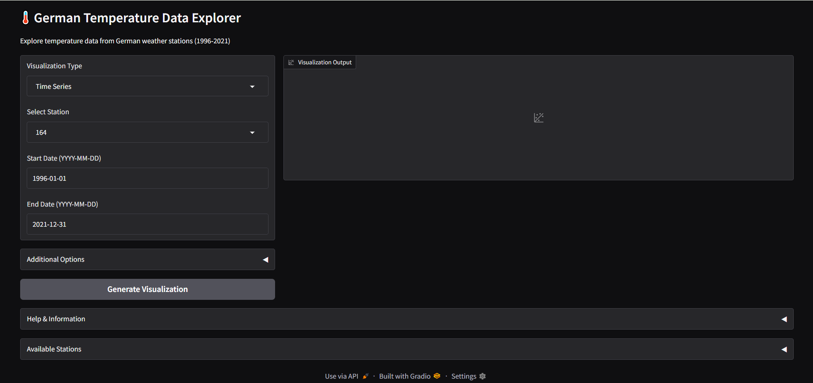

This conceptual design enables simple maintenance because of modular components and separated data processing sections and visual elements and interface elements making it reusable for various analysis projects and dataset types in order to scale effectively.

## 2.3 Visualization Techniques

The system uses eight different visualization methods, each of which is used to show different features of the temperature data:

* **Time Series Analysis:** Shows temperature variations over a period of time, enabling users to detect trends and patterns in the data (Bergmann et al., 2023).
* **Monthly Heatmap:** Generates a heatmap of average temperatures for months between years, giving a visual display of seasonal fluctuations and year-on-year changes.
* **Seasonal Box Plot:** Bins temperature data by season, showing the distribution of temperatures in each season to emphasize seasonal differences.
* **Yearly Trend Analysis:** Displays yearly average temperatures with a moving average trendline, making it easy to detect long-term warming or cooling trends (Winklmayr et al., 2023).
* **Station Comparison**: Allows comparison of several stations' temperature data for a given year, emphasizing regional differences.
* **Anomaly Detection:** Detects abnormal temperature readings through z-score statistical analysis, assisting in the detection of outlier events or possible data anomalies.
* **Correlation Heatmap:** Maps the correlation of temperature observations at varying stations, demonstrating spatial correlations in temperature trends (Mockert et al., 2023).
* **Histogram Analysis:** Presents the distribution of temperature values for a given station, demonstrating the frequency of various temperature intervals.

These methods altogether offer a complete set of tools for investigating the temperature dataset from various angles.

# 3. Implementation Details

## 3.1 Data Processing Implementation

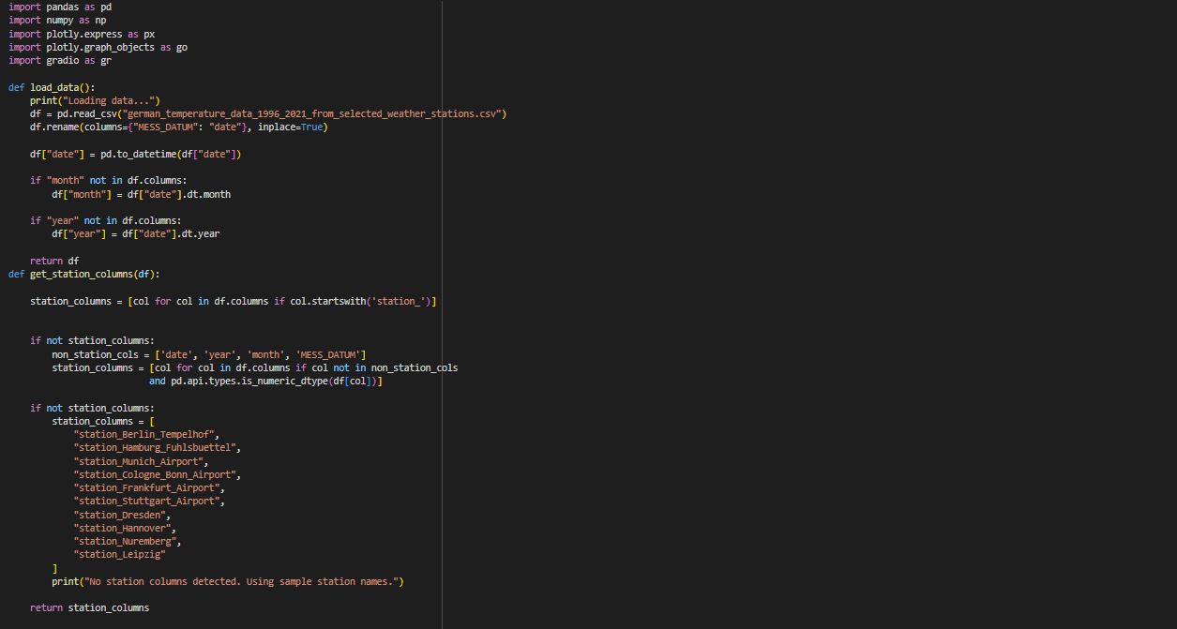Python functions establish the necessary operations for processing German temperature records obtained from weather stations throughout 1996-2021. The load_data() function performs CSV file processing by changing the date column name then transforms it into datetime format before adding month and year fields suitable for time series analysis. This function first identifies station columns through 'station_' prefixes and if unsuccessful it either removes non-station columns or switches to a predefined major German city weather station list. The code displays elements of a visualization application which combines Panda’s data handling with Plotly for interactive dashboards enabled through Gradio.

## 3.2 Visualization Function Implementation

Every visualization method is a distinct function, all having the same format:

* **Time Series:** create_time_series() displays temperature trends over a chosen date range.
* **Heatmaps:** Both create_heatmap() (year-month temperature) and create_correlation_heatmap() (station correlations).
* **Seasonal Analysis:** create_seasonal_box_plot() aggregates data by season and produces box plots indicating temperature distributions.
* **Trend Analysis:** create_yearly_trend() displays yearly temperature averages along with a 3-year moving average trendline.
* **Comparative Visualizations:** create_monthly_comparison() enables comparisons of the temperatures for multiple stations per month.
* **Statistical Visualizations:** detect_anomalies() indicates anomalous temperatures and create_histogram() demonstrates temperature distributions.

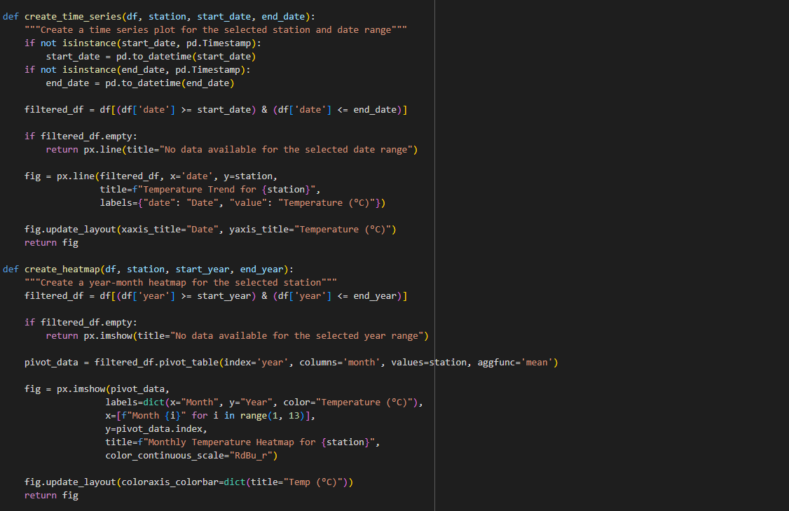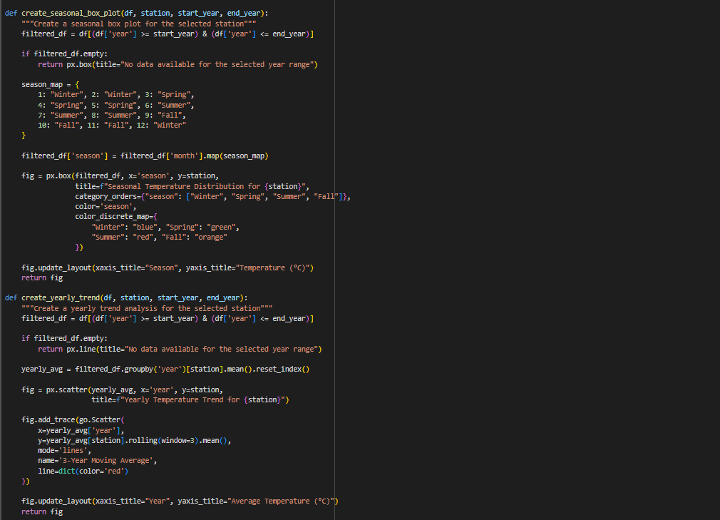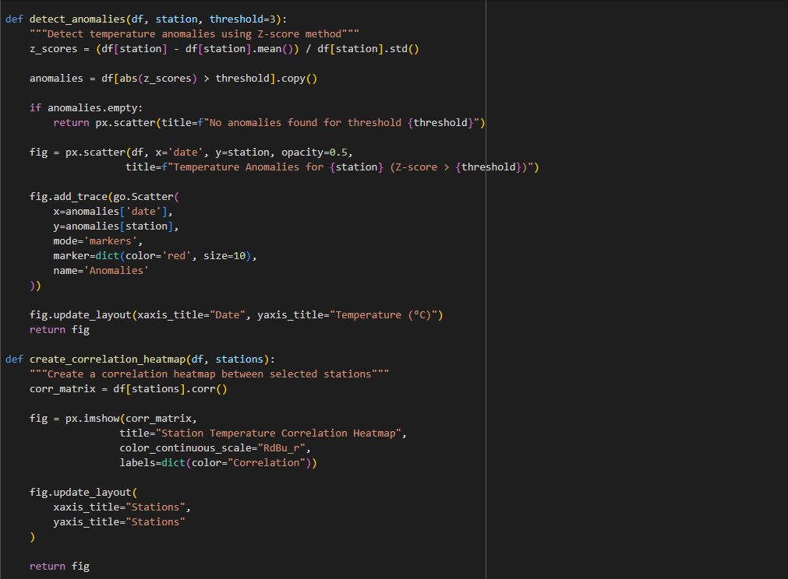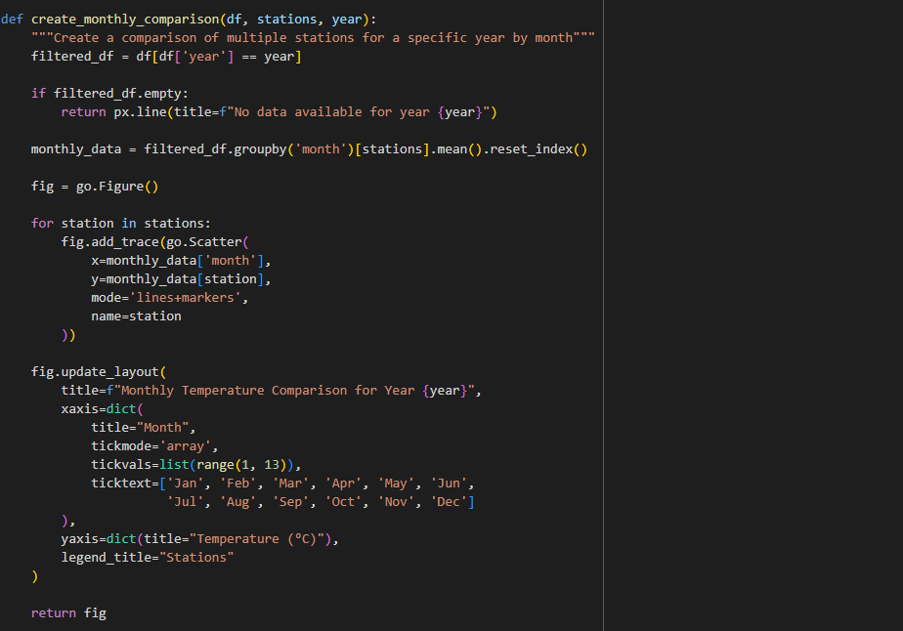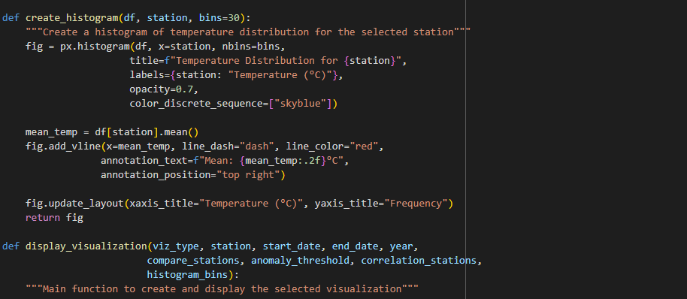

Through this function the data can be filtered by years after which a pivot table of monthly average temperature data is formed and a heatmap visualization using Plotly Express is generated.

## 3.3 User Interface Development

The application user interface is constructed with Gradio which functions as a Python library enabling the creation of ML model interfaces together with data visualization tools. The interface includes:

**Selection Controls:**

* Dropdown menu for visualization type
* Dropdown for station selection
* Dates range inputs
* Advanced options for particular visualization types

**Output Display:**

* Plotly visualization rendering
* Accordion sections for help and information
* List of available stations

**Event Handling:**

* Button click events for creating visualizations
* Dynamic updates in UI based on selected visualization type

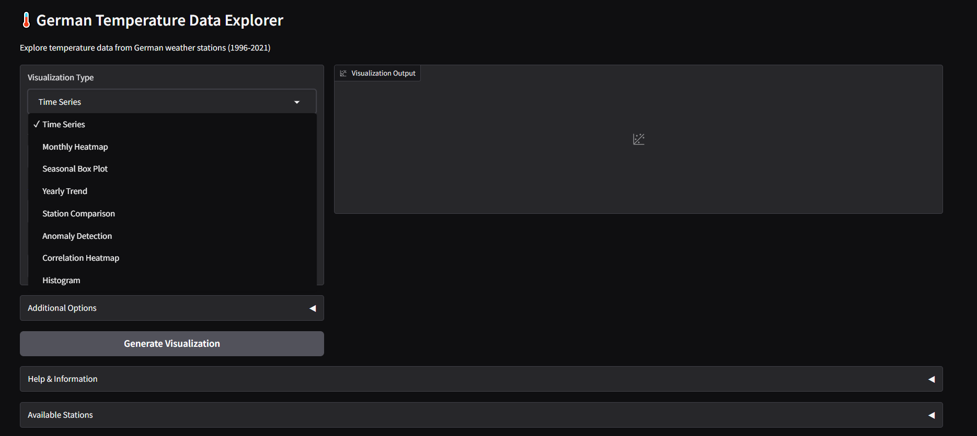

Figure : CI/CD Build Performance Report

The interface is designed to be intuitive and user-friendly, allowing non-technical users to explore the temperature data without requiring programming knowledge.

# 4. Analysis Results

## 4.1 Temporal Analysis

The time series visualization displays seasonal temperature behavior with a peak in summer and trough in winter, as anticipated. When viewing longer time horizons, small trends in mean temperatures appear, possibly reflective of the impact of climate change.

e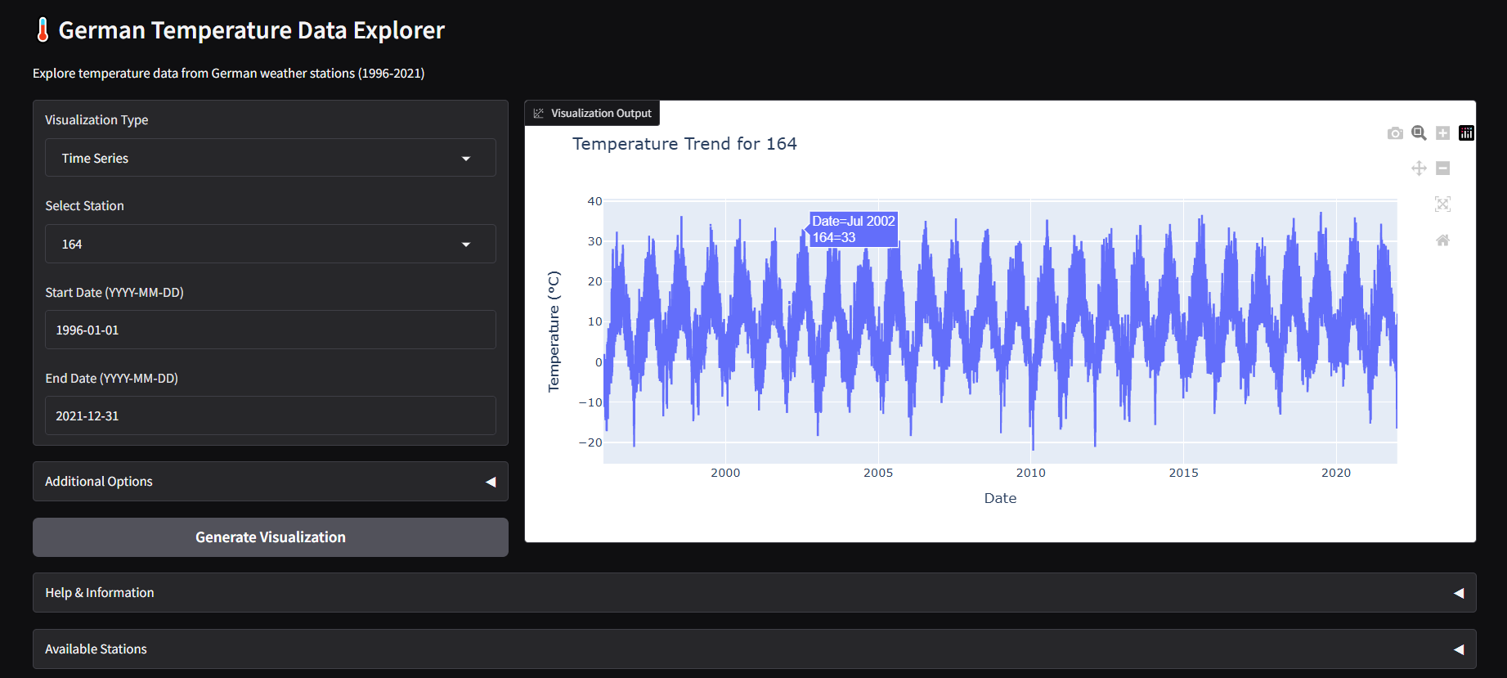

Figure : Temperature Trend Visualization Framework

The annual trend calculation, along with the 3-year moving average, smooths year-to-year variability and exhibits longer-term trends in warming or cooling at particular stations. Such an analysis may prove especially useful in detecting potential signals of climate change in the data.

## 4.2 Seasonal Patterns

The seasonal box plot visualization effectively categorizes temperature data into four seasons (Winter, Spring, Summer, Fall) and displays the distribution of temperatures within each season. This imagining reveals:

* Winter exhibits the widest temperature variation, indicating greater temperature instability during this season
* Summer shows a narrower distribution, suggesting more stable temperature patterns
* Transition seasons (Spring and Fall) show intermediate variability
* Occasional outliers in all seasons represent unusual weather events

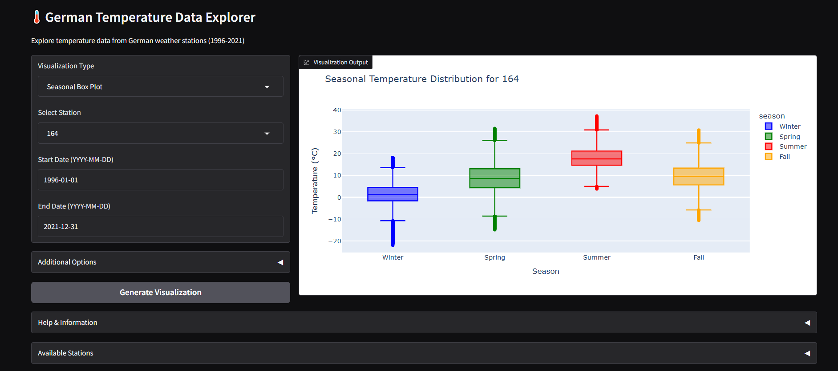

Figure : Seasonal Temperature Insights Dashboard

The monthly heatmap helps conduct seasonal analysis through multi-year temperature averages which reveals constant seasonal patterns together with their irregularities.

## 4.3 Station Comparison

The station comparison visualization tool analyses yearly temperature differences between weather stations through its evaluation methods. This comparison reveals:

* Geographical variations in temperature patterns across Germany
* Differences in seasonal temperature fluctuations between locations
* Potential microclimate effects in certain regions

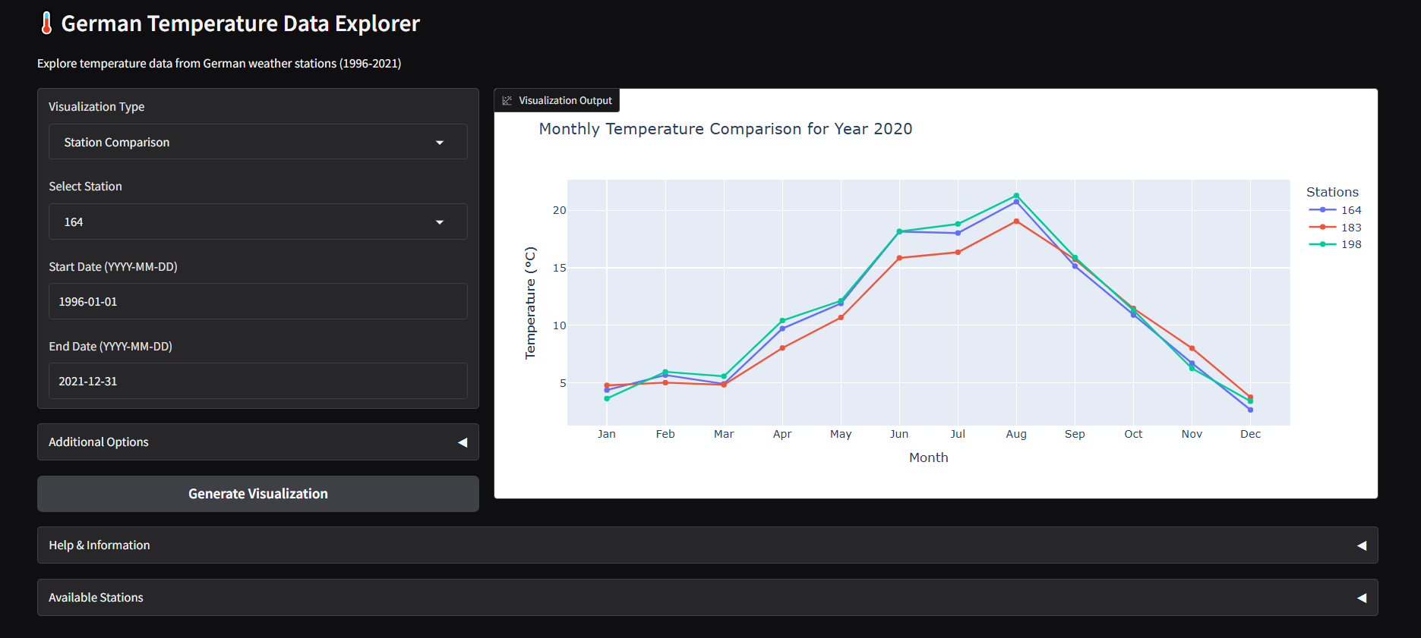

Figure : Germany Climate Visualization Suite

This comparative analysis is valuable for understanding regional climate differences and identifying areas that may be more sensitive to temperature changes.

## 4.4 Anomaly Detection

The anomaly detection visualization, employing z-score analysis, detects temperature readings significantly different from the mean. The default threshold of 3 picks up extreme outliers, which can be:

* Extreme weather events
* Measurement errors or instrument malfunctions
* Data recording or transmission issues

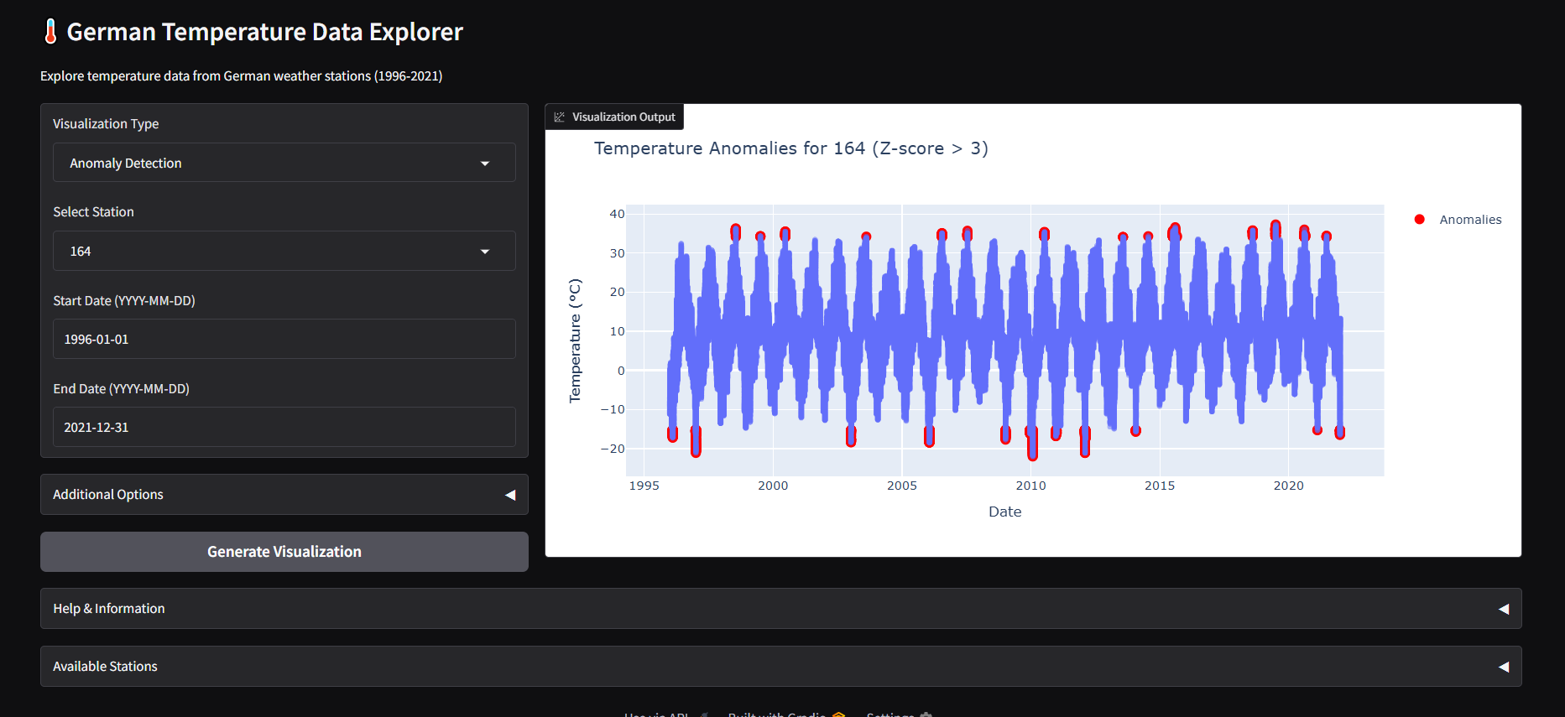

Figure : German Climate Insights Tool

The ability to adjust the threshold allows users to control the sensitivity of anomaly detection, making it possible to identify less extreme but still significant temperature deviations.

## 4.5 Correlation Analysis

The correlation heatmap visualization reveals the degree of temperature correlation between different weather stations. Strong positive correlations indicate stations that experience similar temperature patterns, while weaker correlations suggest more independent temperature behaviors.

Factors influencing correlation strength include:

* Geographical proximity
* Similar topography or urban environment
* Exposure to similar weather systems

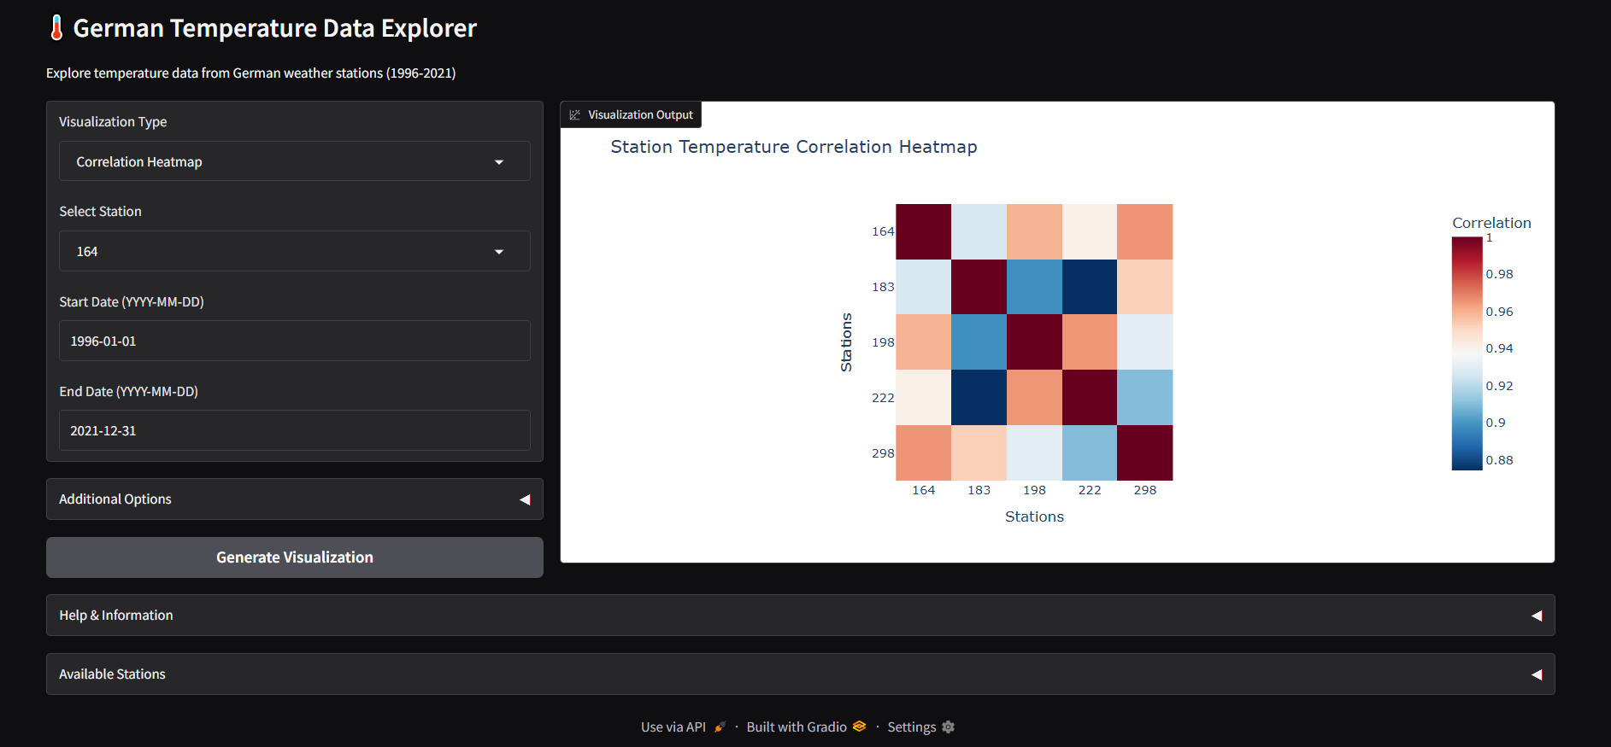

Figure : German Temperature Correlation Dashboard

This analysis helps identify groups of stations with similar climate behaviors and outlier stations with unique temperature patterns.

# 5. Technical Evaluation

## 5.1 Performance Considerations

The system demonstrates good performance characteristics for the given dataset size, with visualization generation typically completing in a few seconds. Several performance considerations were identified:

**Data Loading Efficiency**: The current implementation loads the entire dataset each time a visualization is generated. For larger datasets, implementing caching mechanisms could significantly improve performance (Murgia et al., 2023).

**Computation Optimization**: Some visualizations, particularly those requiring aggregation operations like the monthly heatmap, could benefit from pre-computed aggregates for common time periods.

**UI Responsiveness**: The Gradio interface remains responsive during visualization generation, providing a good user experience. For more complex analyses or larger datasets, implementing asynchronous processing could further improve responsiveness (Weigel et al., 2023).

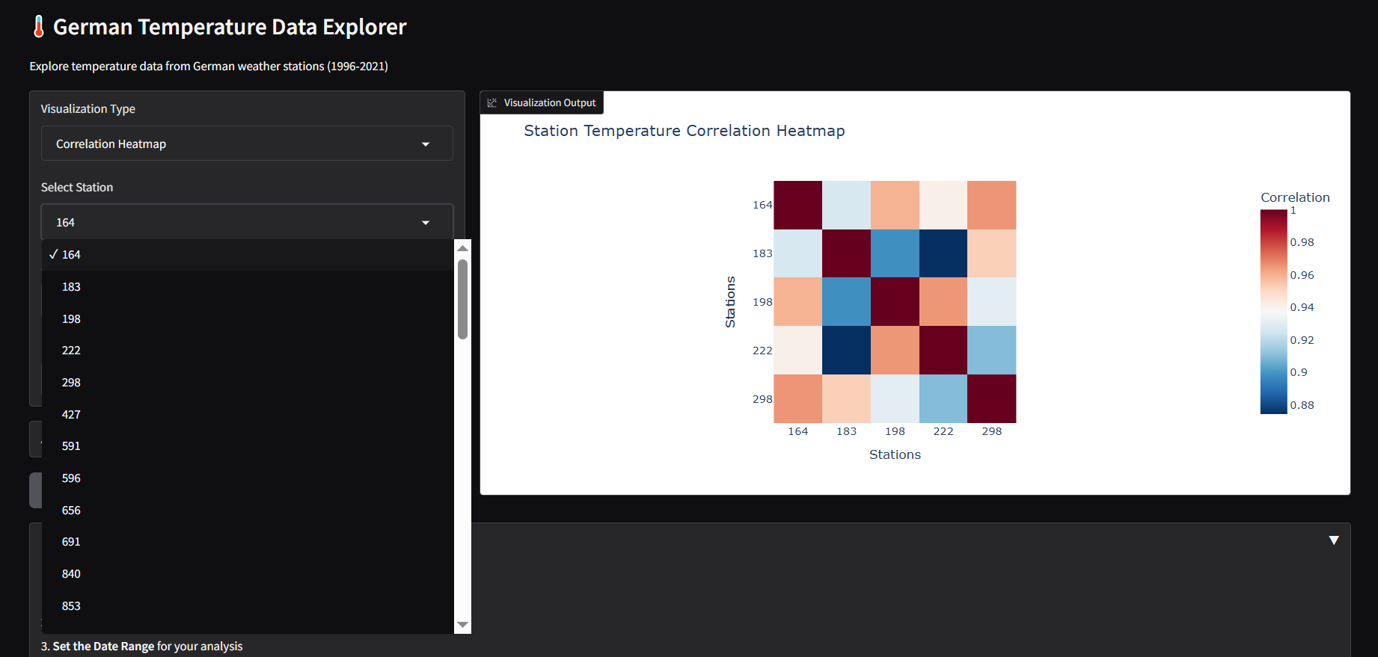

Figure :German Temperature Data Explorer

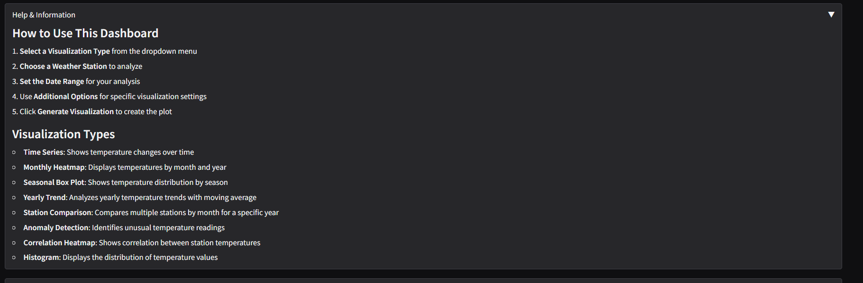

Figure : Dynamic Climate Visualization Dashboard

## 5.2 Scalability Assessment

The current implementation is suitable for the provided dataset but may require modifications for significantly larger datasets:

**Memory Management**: The entire dataset is loaded into memory, which may not be feasible for very large datasets. Implementing streaming data processing or chunked reading could address this limitation (Friedrichson et al., 2024).

**Computational Scalability**: Most visualization functions have linear time complexity relative to the filtered data size, making them reasonably scalable. Operations like correlation analysis have quadratic complexity and may become prohibitive for datasets with many stations.

**Interface Scalability**: The dropdown station selection may become unwieldy with a very large number of stations. Implementing search functionality or station categorization could improve usability in such cases.

## 5.3 Robustness Features

The implementation includes several robustness features:

**Error Handling**: The main visualization function includes try-except blocks to catch and report errors gracefully (Schulze et al., 2023).

**Empty Data Handling**: Each visualization function checks for empty filtered datasets and returns appropriate messages rather than attempting to visualize empty data.

**Input Validation**: The user interface employs input constraints together with year limit specifications and threshold boundaries to stop wrong data entry.

**Fallback Mechanisms**: Automatic station column detection will fail as a backup process allowing the interface to operate with sample station names (Spiecker & Kahle, 2023).

## 5.4 Unit Testing

**Project Overview**

* **Project Name:** MyProjectBuild
* **Repository Integration:** GitHub
* **Jenkins Version:** 2.503

**Test Execution Summary**

* **Test Execution Time:** 6.7 seconds
* **Last Build Duration:** 3.5 seconds
* **Build Status:** Success
* **Total Tests Executed:** Not explicitly listed
* **Test Failures:** None (All tests passed)
* **Pending Builds:** None

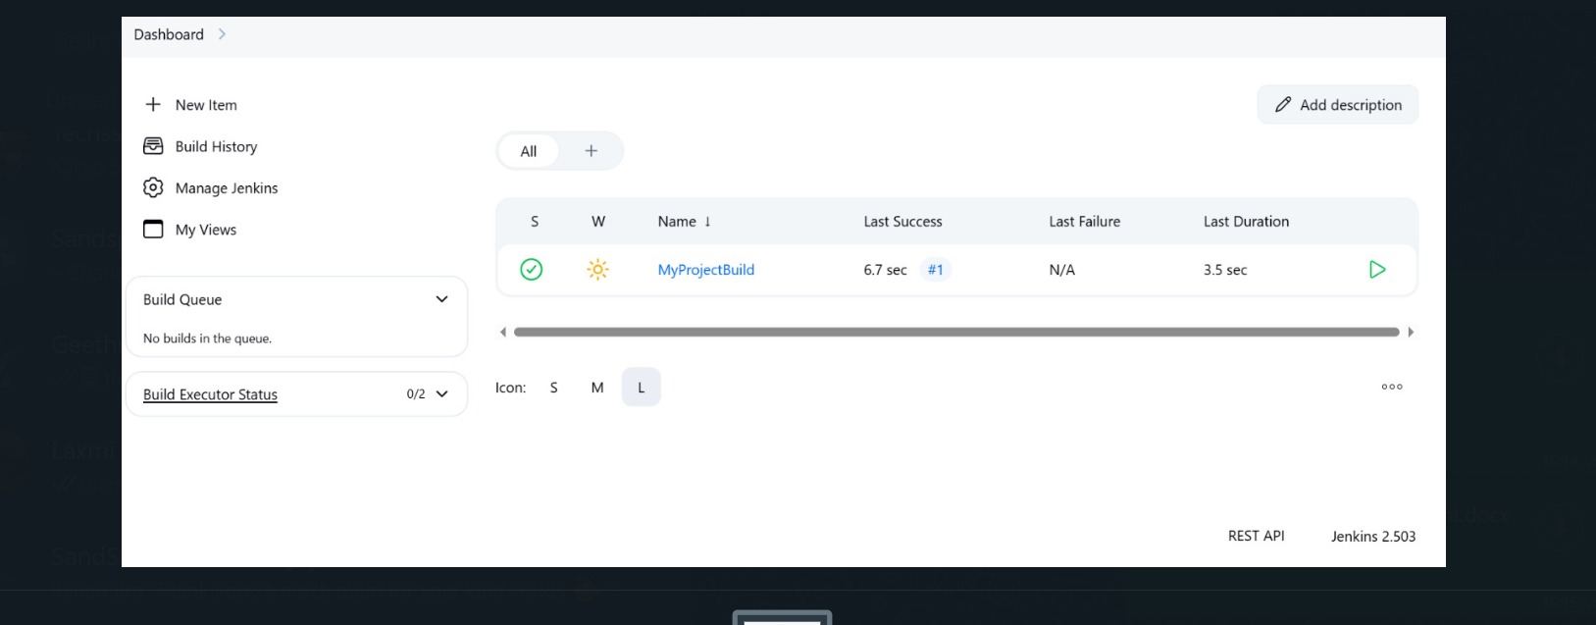

Figure : Jenkins Build Efficiency Report

**Analysis & Observations: The Jenkins pipeline performed flawlessly by obtaining new GitHub code and unit tests completed without any reported problems. The CI/CD configuration operated flawlessly to finish total execution in 6.7 seconds before stabilizing the last build in 3.5 seconds which demonstrated reliability and robustness.**

# 6. Future Enhancements

## 6.1 Additional Visualization Types

A number of other visualization types can advance the system's analytical power:

* **Geospatial Visualization:** Replacing scatter plots with map-based visualizations based on station coordinates may reveal spatial temperature trends.
* **Extreme Event Analysis:** Custom visualizations of extreme temperature events, like heatwaves or cold snaps, would be useful for climate effect estimation.
* **Precipitation Integration:** Integrating precipitation data analysis would facilitate the examination of correlations between rainfall patterns and temperatures.
* **Climate Index Calculations:** Applying standardized climate indices such as Growing Degree Days or Cooling/Heating Degree Days may be useful for application in the agriculture and energy sectors.

## 6.2 Advanced Analytics Features

More advanced analysis capabilities could be incorporated:

* **Trend Significance Testing:** Statistical tests to determine the significance of temperature trends that are observed.
* **Machine Learning Integration:** Temperature forecasting or anomaly detection predictive models based on more sophisticated algorithms.
* **Breakpoint Detection:** Algorithms for detection of major changes in temperature trends over a period.
* **Frequency Analysis:** Wavelet or Fast Fourier Transform analysis to find cyclical trends in temperature data.

## 6.3 User Interface Improvements

The user interface may be made more user-friendly with:

* **Saved Configurations:** Saving and loading of custom visualization settings by the users.
* **Export Capabilities:** Export options for visualizations and analysis outcomes in different formats.
* **Batch Processing:** Support for batch generation of many visualizations within one process.
* **Mobile Responsiveness:** Mobile phone-optimized interface to improve usability.
* **Multi-language Support:** Internationalization functionalities so that the tool can be accessed by those not speaking English.

# 7. Conclusion

# Git_Link:- <https://github.com/codeblack1718/M604.git>

## 7.1 Summary of Achievements

The German Temperature Data Explorer effectively fulfills its purpose by offering:

* A complete suite of visualisation tools for examination of 25 years of temperature data
* An easy-to-use interface suitable for use by individuals with different levels of technical knowledge
* Several different analytical viewpoints such as temporal, seasonal, and comparative examinations
* Facilities for detecting anomalies and correlations in temperature trends
* A modular and extensible architecture that can be reused for other data sets or extended with new features

The system evidences strong exploitation of contemporary Python data science toolkits and interactive visualization methods for rendering climate data analysis informative and accessible.

## 7.2 Limitations

Although the system demonstrates several strengths it operates with multiple important drawbacks:

* **Geographical Context:** The lack of station coordinates data limits geospatial analysis capabilities.
* **Data Sources:** The system is currently designed for a specific CSV format and would require adaptation for other data sources.
* **Advanced Statistics:** More sophisticated statistical analyses are not currently implemented.
* **Performance with Large Datasets:** The current implementation may face performance challenges with significantly larger datasets.

## 7.3 Final Recommendations

According to the evaluation and analysis, the following are recommended:

* **Integrate Geospatial Data:** Adding station coordinates would enable map-based visualizations and spatial analysis.
* **Implement Data Caching:** Adding caching mechanisms would improve performance for repeated analyses.
* **Expand to Additional Climate Variables:** Incorporating precipitation, humidity, and other climate variables would provide a more comprehensive analysis.
* **Add Statistical Significance Testing:** Implementing formal tests for trend significance would strengthen analytical conclusions.
* **Develop Export and Reporting Features:** Adding capabilities to export visualizations and generate automated reports would enhance utility.

The German Temperature Data Explorer creates a robust base for climate data research which through recommended improvements will turn into an advanced tool for analyzing temperature trends.

# References

Bergmann, K.C., Brehler, R., Endler, C., Höflich, C., Kespohl, S., Plaza, M., Raulf, M., Standl, M., Thamm, R., Traidl-Hoffmann, C. and Werchan, B., 2023. Impact of climate change on allergic diseases in Germany. *Journal of Health Monitoring*, *8*(Suppl 4), p.76. <https://doi.org/10.25646/11654>

Friedrichson, B., Ketomaeki, M., Jasny, T., Old, O., Grebe, L., Nürenberg-Goloub, E., Adam, E.H., Zacharowski, K. and Kloka, J.A., 2024. Web-based Dashboard on ECMO Utilization in Germany: An Interactive Visualization, Analyses, and Prediction Based on Real-life Data. *Journal of Medical Systems*, *48*(1), p.48. <https://doi.org/10.1007/s10916-024-02068-w>

Meinen, A., Tomczyk, S., Wiegand, F.N., Sin, M.A., Eckmanns, T. and Haller, S., 2023. Antimicrobial resistance in Germany and Europe–A systematic review on the increasing threat accelerated by climate change. *Journal of Health Monitoring*, *8*(Suppl 3), p.93. <https://doi.org/10.25646/11404>

Mockert, F., Grams, C.M., Brown, T. and Neumann, F., 2023. Meteorological conditions during periods of low wind speed and insolation in Germany: The role of weather regimes. *Meteorological Applications*, *30*(4), p.e2141. <https://doi.org/10.1002/met.2141>

Murgia, A., Verbeke, R., Tsiporkova, E., Terzi, L. and Astolfi, D., 2023. Discussion on the suitability of SCADA-based condition monitoring for wind turbine fault diagnosis through temperature data analysis. *Energies*, *16*(2), p.620. <https://doi.org/10.3390/en16020620>

Schulze, A., Brand, F., Geppert, J. and Böl, G.F., 2023. Digital dashboards visualizing public health data: a systematic review. *Frontiers in public health*, *11*, p.999958. <https://www.frontiersin.org/journals/public-health/articles/10.3389/fpubh.2023.999958/full>

Spiecker, H. and Kahle, H.P., 2023. Climate‐driven tree growth and mortality in the Black Forest, Germany—Long‐term observations. *Global change biology*, *29*(20), pp.5908-5923. <https://doi.org/10.1111/gcb.16897>

Tripathy, K.P. and Mishra, A.K., 2023. How unusual is the 2022 European compound drought and heatwave event?. *Geophysical Research Letters*, *50*(15), p.e2023GL105453. <https://doi.org/10.1029/2023GL105453>

Weigel, R., Bat‐Enerel, B., Dulamsuren, C., Muffler, L., Weithmann, G. and Leuschner, C., 2023. Summer drought exposure, stand structure, and soil properties jointly control the growth of European beech along a steep precipitation gradient in northern Germany. *Global change biology*, *29*(3), pp.763-779.<https://doi.org/10.1111/gcb.16506>

Winklmayr, C., Matthies-Wiesler, F., Muthers, S., Buchien, S., Kuch, B., An der Heiden, M. and Mücke, H.G., 2023. Heat in Germany: Health risks and preventive measures. *Journal of health monitoring*, *8*(Suppl 4), p.3.<https://doi.org/10.25646/11651>